**48th Convention**

WA SSPA Branch would like to invite you to join us for the 48th National SSPA Convention to be held in Perth, WA.

We have a wonderful array of activities to entertain all!



Before we begin we would like to thank our fund raisers.

**SSPA** branches around Australia have contributed to cover the costs of the convention substantially, with the aim of providing a cheap holiday get together for individuals and their families affected by dwarfism.

These are some of the ways the Convention and your participation has been made possible-

SSPA WA members are volunteer drivers donating their cars, fuel & time to take people unable to access bus during the convention, so saving SSPA from hiring a vehicle for the occasion.

Rottnest Express Ferry is paid for by WA SSPA Fundraising,

DJ- $150 donated by Allan & Eleanor Snook towards cost of DJ hire, SSPA NSW has also contributed to cover the DJ costs.

extra Dinner Dance costs are paid by fundraising, such as kitchen & venue hire, table cloth hire, contributions from SSPA Nth QLD

Girl Guides Association has kindly donated time and equipment to provide activities and supervision for our children on the Medical Day and for the Dinner Dance, as suggested by Irene & Hiki Hiku and their daughter, Te Aroha, a Girl Guide and part of the WA SSPA group. They have also kindly offered table centre pieces for our Dinner Dance to make the occasion even more special for us!

Spare Parts Puppet Theatre costs donated by Jo & Terry Bracknell.

SSPA Travel Fund- offered a subsidy to SSPA members travelling to Perth. This years travel fund was sponsored from funds from the 2014 Adelaide National Convention , SSPA SA.

Costs of hosting medical professionals for the SSPA Medical Day, such as accommodation, linen & meals, has been funded by SSPA WA, particularly the Bunning Bque fundraiser early this year, thanks to all who assisted.

Eleanor, Allan, Lena & Gemma Snook will set up the Dinner Dance venue with tables, chairs, table cloths & centrepieces. They will also pack it all up, and clean up Thurs morning before we go onto Perth CBD.

Bus, 42 seater; partially funded by SSPA Victoria (rest of bus costs donated by Leon Franklin)

Disablity Works Australia, Tina Zeleznik, has assisted with rubber ramp hire to assist access to the buildings.

Please take the opportunity to thank these individuals and their SSPA Branches for their sponsorship for our 2015 National Convention, we extend out thanks to the businesses & their communities for assisting with fundraising.

**DAY 1; Sunday 27th Sept**

Registrations 2pm - Arrive at Woodman Point Recreation Camp and book in at the **Dining Hall** where you will find Suzann Franklin, Jo Bracknell and Erica Grant, (please see map included in your booking confirmation or check the sign on arrival to the car park). Dining Hall is the building set back & on the right of the picture above.

You will be given your welcome pack, and your room number. You will also likely find lots of other friends to catch up with!

If you are travelling by private vehicle, don't forget to have the security gate code handy to unlock the camp gate. This will be supplied the security gate code with your registration confirmation. Registration forms will become available shortly.

Please take lots of photos to share on Friday night on our data projector with the group. Simon Franklin, Lena & Gemma Snook will be setting up a 2015 SSPA National Convention Photos & Reminiscing display Friday night after dinner and will need help with everyone’s photos. Please see them regularly throughout the week to upload your photos to the display.

Please let us know if you do not wish your photo to be displayed.

Afternoon tea at 3pm.

**Quick Shopping trip-** Bus, and car departs 3.30pm from Woodman Point Front Office Car Park for Phoenix Shopping Centre, Spearwood. Departing Shopping Centre at 4.45pm for camp.

Dinner at 6pm

**PJ's, Plonk & Pretzel** evening commencing at 7:30pm in the Dining Room. As the name suggests, you must have your PJ's on, and be ready to meet new friends, and reminisce with old ones!

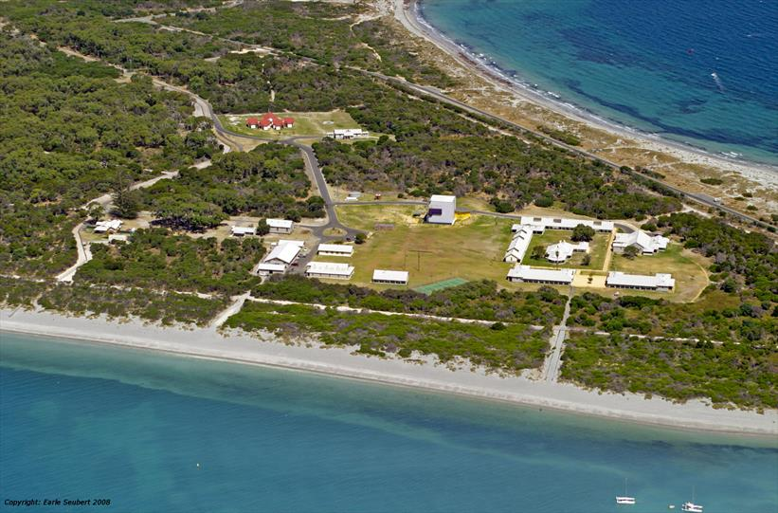

**DAY 2; Monday 29th Sept SSPA Medical Day**

The 2015 medical day will feature presentations from some of Australia's leading genetic and bone dysplasia specialists as well as various workshops in the afternoon. More details will be distributed to online mailing lists and social media platforms as they are finalised.

Activities & supervision will be provided for younger conference participants by Girl Guides and their Team Leaders.

**Quick Shopping trip-** Bus and car departs 4.00pm from Woodman Point Front Office Car Park for Phoenix Shopping Centre, Spearwood. Departing shopping centre at 5.15pm for camp.

After Dinner we will have our **“P Theme Disco”,** so start thinking about dressing up as something starting with the letter “P”. Why not come as a pirate, a panda, a princess, a pumpkin, a parking meter attendant! Your options are endless!

**DAY 3; Tues 30th Sept**

**Rottnest Island**

We will take our bus and cars to to the North Port (Rous Head) FerryTerminal, where we will board the **Rottnest Express Ferry** for a short 45 min ocean trip to Rottnest Island. This exciting opportunity has been fundraised for you by SSPA WA. Once at Rottnest you have the option to wander as you wish. Your choice of activities and lunch is at your expense.

Explore the Island with this fun, convenient multipurpose **Island Explorer Bus Service.** Jump off at your favourite bay, climb the Lighthouse, visit West End or just kick back, enjoy the ride and spectacular views.

Bus timetables can be seen at every bus stop or pick-up a bus timetable and purchase your all-day rider from the

Rottnest Island Visitor Centre or Main Bus Stop vending machines. Adult $20.00; Concession $16.00; Child $12.00;

Family (2x2) $50.00; Extra Child $5.00; One Way $10.00.

Departing 11:15am 12:30pm 1:45pm. One hour round trip of Rottnest.

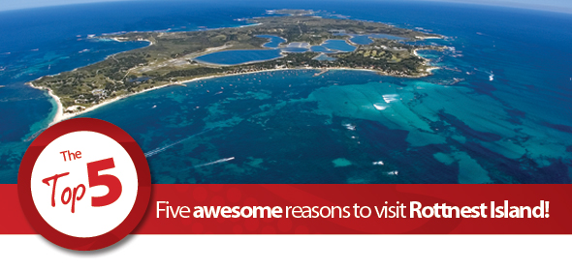

### Rottnest’s unique array of wildlife

Standing just 12 inches tall, the Quokka is Rottnest’s most famous inhabitant. With 8,000-12,000 inhabiting the Island, you’re sure to spot one. View the annual migration of Humpback Whales from September – November. Get up close and personal with a colony of New Zealand Fur Seals at Cathedral Rocks, plus Ospreys and pods of Dolphins.

### Activities galore

Jump onboard a 90 minute Rottnest Adventure Tour or afternoon Whale or Seal Encounter and explore the Island by sea. Or feel the wind in your hair as you use pedal power to explore the Island’s many treasures by bike. With cars excluded on the Island, bike riding would have to be the most popular and fun way to explore the Island. Take to the air on a 10 minute joy flight or visit the Rottnest Bike and Hire store to grab your very own Surfboard or Stand-up Paddle Board for the day.

### Historical Rottnest

A guiding light, a defender of the peace, hunting ground and prison. Rottnest boasts an incredibly rich heritage. Take a tour up to Oliver Hill on the Captain Hussey, sit back on a Discovery Coach Tour or view relics at the Rottnest Museum, Lomas Cottage and Pilot Boat House. Keep an eye out for the yellow shirt clan, the Rottnest Volunteer Guides, offering an array of informative walking tours.

### White sandy beaches

The Island’s breathtaking natural beauty has to be one of Rottnest’s biggest assets. This vast natural playground has over 63 beaches and 20 bays so there is a high possibility of finding a secluded beach all to yourself. Rottnest is teeming with more than 135 species of vibrant tropical fish and 20 species of coral. Snorkelling is the best way to explore Rottnest’s underwater playground. Be sure to check out the underwater snorkel trail located at Parker Point.

### Family fun

Rottnest Island has a great range of activities to keep the family entertained for hours! Located just a short walking distance from the main settlement is the Family Fun Park. Mini Putt Putt, Trampolines, Air Soccer, Ping Pong plus a variety of family games are available. At certain times of the year you can watch your favourite movies at the Rottnest Picture Hall.

**DAY 4 Wednesday 30th Sept**

Today you will attend the **AGM.** The AGM is an integral part of the running of the SSPA. All members can discuss anything they may wish with the group. Another important aspect of the AGM, is that you need to select your new national council for the 2015 / 2016 year. This comprises of the SSPA elected President, Vice President, Secretary, Treasurer, and your National Council representatives! This is your chance to nominate who you would like representing the SSPA in your state AND to put your voice forward! You can discuss whatever you feel is important to YOU! Don't sit by and wish you had of said 'something' come along and open up your thoughts for discussion. Don't worry though you will get morning tea during the AGM and a short break, before it continues!

In the afternoon if you are elected to **National Council**, the first meeting for 2015 / 2016 will be held, so you will be required to attend. If you do not have a position on National Council, you have a free afternoon, to do as you wish! Explore the beautiful grounds of Woodman Point, book in and pay for a flying fox Cube Adventure, do some shopping, or have a well deserved afternoon nap! The choice is yours.

**Optional extra; The Cube Adventure Program- 12.45pm to 2.30pm (1.5hr)**

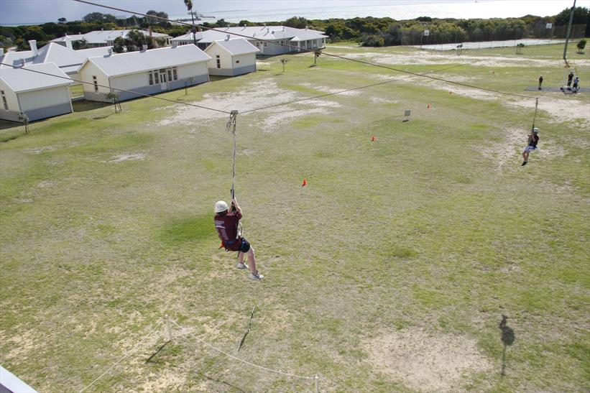

Woodman Point offers “The Cube” and WA Government Department of Sport and Recreation employ a team of dedicated and highly qualified outdoor instructors to deliver and facilitate the camp’s adventure programs. Full body harnesses are available.

Convention participants will have the opportunity to book a position for the flying fox. **There is a maximum of 16 places available. These activities will cost an extra $25 / person to participate.** Please add an extra $25 to your registration fee if you would like to book a place, first to book secure a place.

**Optional extra; Woodman Point Heritage Tour- one hour 3.30pm – 4.30pm**

In the 1880s a [quarantine station](http://en.wikipedia.org/w/index.php?title=Woodman_Point_Quarantine_Station&action=edit&redlink=1) was established there to isolate immigrants from the community whilst being cleared of [smallpox](http://en.wikipedia.org/wiki/Smallpox), [bubonic plague](http://en.wikipedia.org/wiki/Bubonic_plague) and [Spanish influenza](http://en.wikipedia.org/wiki/Spanish_influenza) which was ravaging Europe, the Americas and Asia.

Records show that from the 1830’s sea passengers and cargo were quarantined at the station, but it was not until 1885 that the first building was completed on the grounds. Keeping highly infectious diseases such as Bubonic Plague, Smallpox, Spanish Flu and Tuberculosis from entering Western Australia was a fulltime mission and sadly, over 3oo people lost their lives over the years including many nurses and doctors.

The station was officially closed in 1979 and is now managed by the State Government as a recreation camp. The government has poured a considerable sum of money into renovating the station’s buildings, bringing them to their former glory (right down to the colour schemes apparently) and they have done a truly magnificent job.

**This tour is an optional extra for an extra $11.50 per person. There are 16 places available.**

Please add an extra $11.50 to your registration fee if you would like to book a place, first to book secure a place.

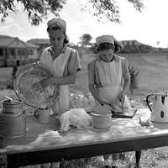 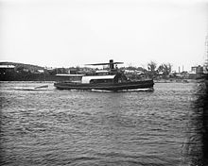

**Quick Shopping trip-** Bus and car departs 3.45pm from Woodman Point Front Office Car Park for Phoenix Shopping Centre, Spearwood. Departing shopping centre at 5.00pm for camp.

**Dinner Dance**

Tonight is the night of nights, and the very much anticipated 'Dinner Dance'! This is a very special occasion for those of you over 13 yrs to attend the formal part of the convention. Should there be a recipient, the McHugh Henderson award will be presented to this person on the night. There will be food, there will be dancing, there will be singing, there will be lots of fun that you will be involved in!

For all of you 12yrs and under, you have a VERY exciting night ahead too! You will be having your own Tea Party with some carers at Woodman Point Camp. You too are invited to have a wonderful fun evening, with dancing, movies, and lots of yummy food.

**Day 5 Thurs 1st Oct**

We will travel to the Perth Central Business District (CBD) today.

You have a variety of options to choose from at your expense, such as a Cultural theme, or maybe the Scitech or just stroll the shopping precinct for a bargain or memento of sunny Perth. We will then meet back at a designated location to come home together.

Also on offer will be a range of free activities, with details becoming available closer to the date.

The Perth Cultural Centre is made up of a number of organisations in buildings spread through a central precinct in the heart of Perth.   
  
These include the Western Australian Museum, the Art Gallery of Western Australia, the Library and Information Service of Western Australia, the Perth Institute of Contemporary Arts and The Blue Room Theatre.

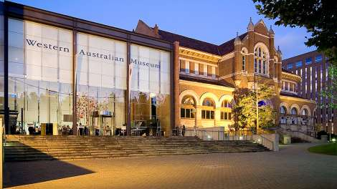 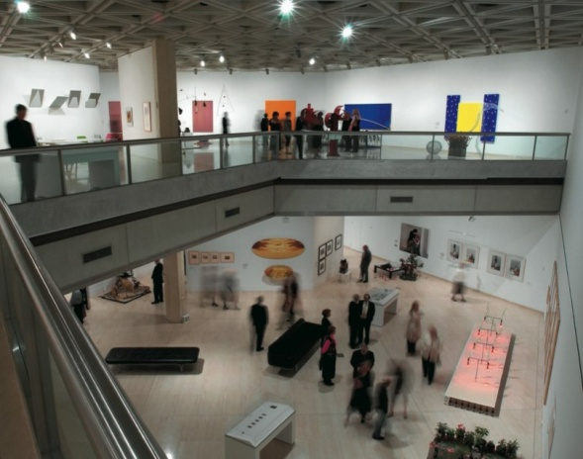

Perth Cultural Centre;

Art Gallery of WA

Through the Collection, our associated programs, and stimulating exhibitions Gallery visitors' are offered a unique and exciting experiences of historic and contemporary Australian artists, and bring the art of the world to Western Australia.

Situated in the Perth Cultural Centre, the Art Gallery of WA is conveniently located within easy walking distance from the Perth train station, and is accessible from most Perth-bound bus routes.

|  |
| --- |
| **WALKING** Entry from the City is best taken via the Perth Train Station and Roe Street pedestrian overpass, or from Barrack Street via the James Street Mall. **RAIL** AGWA is easily accessed by the pedestrian over-pass from the Perth Train Station. On alighting from your train follow signs for 'Eastern Concourse'. Take the lift or the escalators to the top; proceed through the barriers and turn left.  You will cross the bridge immediately before arriving at the Gallery to your right.  Transperth recommend that those travellers requiring special assistance at train stations contact them on 1800 800 022 for further details. This is a 24 hour service. For more information on routes, timetables and services contact Transperth's InfoLine on +61 9 9428 1900 (overseas and interstate visitors) or 13 62 13 alternatively visit [Transperth](http://www.transperth.wa.gov.au/) online. **BUS AND TAXI** Transperth's Blue CAT buses provide the closest pick-up and drop-off points for the Art Gallery at the Museum Stop on Beaufort St.  Taxi and special group buses are temporarily permitted to drive into the Cultural Centre to within 30m of the Main Gallery entrance for set-down and pick-up purposes only.  Please inform your driver to enter James St via Beaufort St.  Longer-term parking is strictly prohibited. |

**OPENING HOURS**

Day: Wednesday - Monday

Time: 10am - 5pm

|  |
| --- |
| ENTRY FEES  While the Gallery is free to visit, we do ask all visitors to make a voluntary donation as you enter.  Through the Collection, our associated programs, and stimulating exhibitions Gallery visitors' are offered a unique and exciting experiences of historic and contemporary Australian artists, and bring the art of the world to Western Australia. Perth, Western Australia Geo code for GPS: -31.950414,115.860604  **WA Museum** **Phone** 1300 134 081  The Western Australian Museum is the State’s premier cultural organisation, housing WA’s scientific and cultural collection. For over 120 years the Western Australian Museum has been making the State's natural and social heritage accessible and engaging through research, exhibitions and public program.  Admission  Free Entry. Suggested donation $5. Some touring exhibitions may attract admission fees, please check the [exhibition listings](http://museum.wa.gov.au/whats-on/exhibitions/perth) for details.  **Play Space – Perth Cultural Centre**  Based on nature and sound, the play space focuses on climbing, balance, energy, music, texture and educational play - sensory elements to inspire young people’s imagination and creativity.  Please note, the Play Space will be closed for a few months while heritage conservation works are underway on the WA Museum, in preparation for the New Museum of WA.  In the meantime, we'll be doing some work to make the Play Space better.  There's still plenty to [see and do](http://www.mra.wa.gov.au/projects-and-places/perth-cultural-centre/resolveuid/7287e61bc73e4c47953d69a88a823fac)in the Perth Cultural Centre.  The Play Space is located in the James Street Mall main pedestrian way in the Perth Cultural Centre, in front of the WA Museum.  Instruments such as chimes and beaters, a colourful set of melodic drums and a series of interconnected talking tubes, create a soundscape for children to explore and experiment with. Movement, balance and energy are also encouraged throughout the play space with walking stilts, low steppers and climbing rocks. The play space was recognised with a design award by the Landscape Industry Association of WA (LIAWA).   * Play Space   Perth Cultural Centre James Street Mall - outside the WA Museum (Bordered by Roe Street, Beaufort Street, Francis Street and William Street) [(08) 6557 0700](tel:(08)%206557%200700) |
|  |

Shop local and luxury

Designer labels rub shoulders with local brands along King, Queen, Hay and Murray Streets in Perth city. Browse the boutiques for fine jewellery crafted from Western Australian gold, Argyle diamonds and Broome’s famous South Sea pearls. Or, if vintage, hip and quirky is more your style, make a beeline for the boutiques of William Street in Northbridge.

Plan a tour

Hop on a free CAT bus and tour Perth’s unique array of attractions. Play one of the world’s largest musical instruments – the bell tower. See a live gold pour and the world’s largest collection of gold bars at the Perth Mint. Catch a ferry across the Swan River to view Perth Zoo’s collection of more than 1,500 animals.

Perth Bell Tower Barrack Square Riverside Dr, Perth WA 6000

The **Swan Bells** are a set of 18 [bells](https://en.wikipedia.org/wiki/Bell_(instrument)) hanging in a specially built 82.5 metres (271 ft)-high copper and glass [campanile](https://en.wikipedia.org/wiki/Bell_tower) in [Perth, Western Australia](https://en.wikipedia.org/wiki/Perth,_Western_Australia). The tower is commonly known as **The Bell Tower** or the **Swan Bell Tower**.[[1]](https://en.wikipedia.org/wiki/Swan_Bells#cite_note-1)[[2]](https://en.wikipedia.org/wiki/Swan_Bells#cite_note-2)

Taking their name from the [Swan River](https://en.wikipedia.org/wiki/Swan_River_(Western_Australia)), which their tower overlooks, and forming a sixteen-bell peal with two extra [chromatic](https://en.wikipedia.org/wiki/Chromatic_scale) notes, they are one of the largest sets of [change ringing](https://en.wikipedia.org/wiki/Change_ringing) bells in the [world](https://en.wikipedia.org/wiki/World).

The Bell Tower located on Riverside Drive overlooking the picturesque Swan River is one of Perth's most unique and must see tourist attractions. Filled with fascinating historic content and boasting a unique and distinctive design - resulting from a major architectural competition - it has become an icon for Perth and Western Australia.

The Bell Tower accommodates and provides for the needs of a wide variety of visitors and is designed to ensure visitors with physical disabilities are able to have full access to the area.

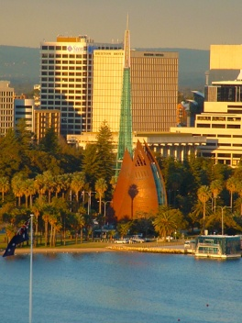

***ENTRY FEES***

|  |  |
| --- | --- |
| Adults | $14 |
| Children | $9 |
| Concession | $9 |
| Family | $30 |

***CONCESSION ENTITLEMENTS***

* Children 5 – 14
* Australian Government senior cardholders
* Centrelink cardholders
* Fulltime student cardholders
* Companion Card for disability carers

A valid concession card must be produced to gain concession entry  
  
Children under the age of 5 are permitted free of charge  
  
An adult must accompany children under 12 year

The Bell Tower is the only place in the world where bellringers can share their cultural heritage with visitors in such an open and accessible way.   
  
You can hear the Ringers practicing their ancient art of 'Change Ringing' at the following times.  
  
**FULL BELL RINGING**

|  |  |  |
| --- | --- | --- |
| Monday | Noon - 1pm | (12:00pm - 13:00pm) |
| Thursday | Noon - 1pm | (12:00pm - 13:00pm) |
| Saturday | Noon - 1pm | (12:00pm - 13:00pm) |
| Sunday | Noon - 1pm | (12:00pm - 13:00pm) |

The bells are also rung on many other occasions, with 10-bell practices and Surprise Major Practices being held monthly. Contact the ringers for more information.   
You can experience Bell Handling demonstrations with one of our volunteer Ringers on the following days.  
  
**BELL HANDLING DEMONSTRATIONS *(single bell)***

**Perth Mint-**

As one of Western Australia's leading tourist attractions, The Perth Mint offers a unique combination of activities, exhibitions and demonstrations, enabling visitors to experience the astonishing allure of gold.

Established as a branch of Britain's Royal Mint in 1899, The Perth Mint's primary functions to refine gold from Western Australia's eastern goldfields and strike gold coinage continue to this day, with precious metal coins struck onsite at the Mint, and gold refined at The Perth Mint Refinery, situated near Perth Airport.

The Perth Mint is located at 310 Hay Street, East Perth, a short walk from the City centre and many of Perth's leading hotels.

The free [Red CAT](http://www.transperth.wa.gov.au/timetablepdfs/Perth%20CAT%20Timetable%20203%2020150201.pdf) bus service is convenient for The Perth Mint. Click here to view [CAT bus route.](http://www.transperth.wa.gov.au/timetablePDFs/Perth%20CAT%20203%2020130630.pdf) Alight at The Perth Mint CAT bus stop (number 6).

**Tours**

A tour consists of a Guided Talk, entrance in to The Perth Mint Gold Exhibition and Gold Pouring demonstration

|  |  |
| --- | --- |
| Weekdays | 9.30am, 10.30am, 11.30am,12.30pm,1.30pm, 2.30pm and 3.30pm |

**Admission Prices**

|  |  |
| --- | --- |
| Adult | $19.00 |
| Concession Card Holder | $17.00 |
| Children (4 to 15 years) | $8.00 |
| Children (0-3 years) | no charge |
| Family Pass (two adults/two children) | $45.00 |

Disabled accessible.

**Perth Zoo**

**Perth Zoo is located at 20 Labouchere Road, South Perth.**

Australia’s best small zoo is just 5 minutes from the Perth CBD on the banks of the Swan River. Perth Zoo is open every day of the year – in fact it has not closed for a single day since it opened back in 1898. You will need at least half-a-day to see everything Perth Zoo has to offer but we recommend a full day to make the most of your visit.

BY FERRY

Perth Zoo is a short walk from the Mends Street Jetty in South Perth. Ferries depart from the Barrack Street Jetty (across the river in Perth) every half-hour during the day, and quarter-hour at peak times.

For further information on ferry timetables and prices please call Transperth information on 13 62 13 or visit[www.transperth.wa.gov.au](http://www.transperth.wa.gov.au/).

**BY TAXI**

Any of Perth’s taxi companies can bring you directly to Perth Zoo. These can be hailed on the street or ordered by telephone. Two of Perth’s major taxi companies are:

**Swan Taxis** 13 13 30  [www.swantaxis.com.au](http://www.swantaxis.com.au/)

**Black & White Taxi** 13 10 08

Zoo Charges;

|  |  |
| --- | --- |
| **Adult** (other than Seniors and Concessions) | $29.00 |
| **Children** **(4-15 yrs)** Children under 15 must be accompanied by an adult ($9.75 for students on a pre-booked school excursion) | $14.00 |
| **Australian Concession** (other than Seniors) - Australian Health Care Card holders & Students over 15 years of age | $22.00 |
| **Seniors** (on presentation of Government issued Aged Pension or Seniors Card) | $22.00 |
| **Mini-Group** (2 adults and 2 children) | $75.20 |
| **Children under 4 yrs** | FREE |

Disabled accessible

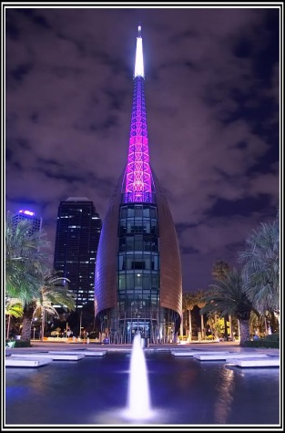 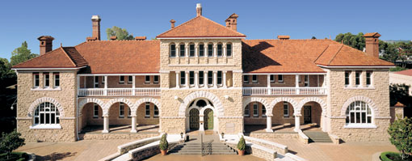  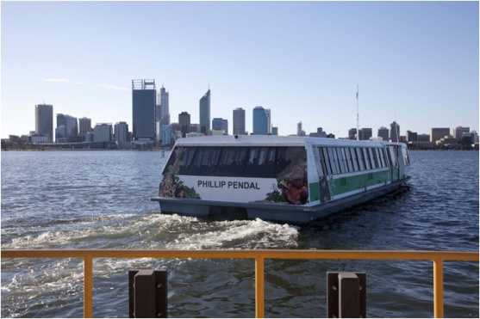

## Scitech

The Scitech features a number of regularly changing interactive exhibitions designed to inform and educate visitors on a myriad of subjects concerning science, technology, engineering and maths (STEM). It also offers a range live science, puppet and planetarium shows presented by enthusiastic science communication staff.

Large feature exhibitions are rotated every six months, with a variety of STEM exhibits pertaining to a particular theme, storyline or concept, most of which are built in-house by Scitech's design, graphics, and workshop departments. Scitech was the first Australian science centre to build large-scale interactive exhibitions. In addition, the exhibitions Scitech creates have also toured nationally and internationally to places including Sydney, Melbourne, Adelaide, Brisbane, Darwin, Singapore, United Kingdom, Hong Kong, New Zealand, Finland, France, England, Portugal, Estonia, Norway, Kuwait, and will soon be appearing in North American venues.

Approximately 3 million people have visited Scitech since its opening in 1988. 290,000 general public visitors and 45,000 school children visit the Scitech Discovery Centre annually at its West Perth base, with another 180,000 people experiencing Scitech via its travelling roadshow known as Outreach.

Disabled accessible.

Scitech Entry costs-

Adults $17

Child $11

Under 4yrs Free (No entry to Planitarium)

Concession $14

Mini Groups $48

2 adults & 2 kids, or

1 adult & 3 kids

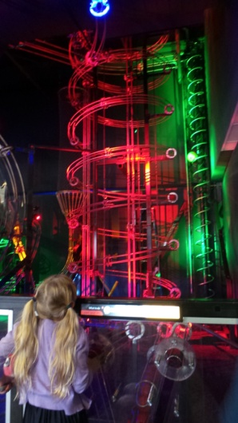 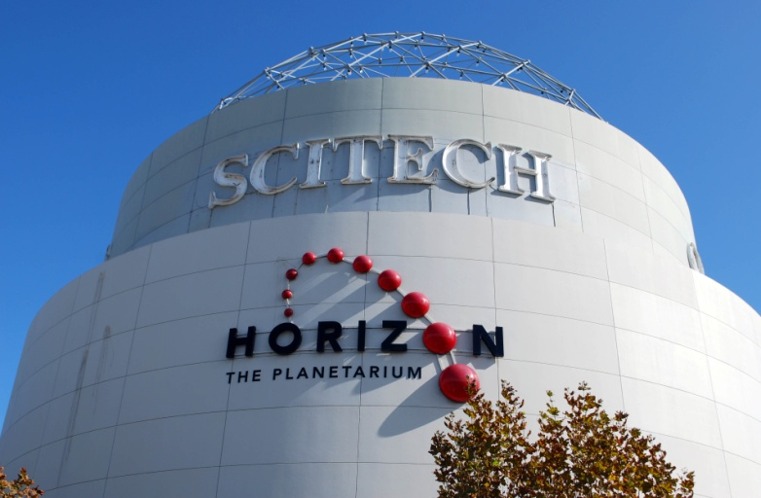

Thursday afternoon

Leave Perth CBD at 1.30pm for camp.

At 2.30pm start either Letters to Myself or possible Medical guest speaker may be able to join us. With Letters to Myself postponed till 4.15pm.

The SSPA Short Arts collective will be hosting a "Letters to Myself" session with the view to publishing a second edition of this much sought after book!. "Letters to Myself" is a compilation of personal letters written by short statured people of all ages, and parents of short statured children to themselves either in the past or in the future. Each piece is unique, and is certainly something to treasure.

Thursday Evening –Bingo

Join us for a few entertaining rounds of Bingo, a game of chance!

**Day 6 Fri 2nd Oct**

Friday morning

9am Daily Living Centre comes to SSPA

Come and learn about adaptions to assist individuals with the independent living, presented by Centre team. The Independent Living Centre WA (ILC) provides information and advice, assessment, training, funding and hire services that enable Australians of all ages and abilities to live more independent and fulfilling lives. ILC’s can be found Australia wide.

10.30am Sports Day at Woodman Point Beach and grounds. With action packed program of activities waiting for you.

10.30am Spare Parts Puppet Theatre (SPPT) - Australia’s champions of puppet theatre.

Spare Parts Puppet Theatre presents four seasons a year at Fremantle, they nurture the art form through their School of Puppetry & Emergent training program – FirstHand, performing in Festivals, corporate & community events & touring extensively thoughout regional West Australia and the world.

Spare Parts Puppet Theatre was founded in 1981 as part of an artist-in-residence program initiated by Curtin University of Technology and are now share the magic of puppetry with over 50 000 people annually.

Events Workshops

Puppet making workshops can be a great hands-on activity to be enjoyed by children and adults. Workshops are free flowing and can be tailoered to our event and you can take your puppet home as a momento.

1.45pm Discover the vibrant port city of Fremantle

The best preserved 19th century port streetscape in the world provides a striking stage for a vibrant café, shopping, arts and cultural events scene. Inside a single day you can discover Fremantle’s maritime and convict history, experience the buzz of the iconic Fremantle Markets, taste the freshest seafood, sample the finest hand-crafted beers and hang-out with the locals on Cappuccino Strip. Explore Fremantle.

(Free activities information will be available closer to the date.)

**Fremantle Prison -**

**Doing Time Tour**

Step inside and join our experienced guides as we explore Fremantle Prison from its convict origins in the 1850’s until its closure as a maximum-security gaol in 1991. Take a visual journey back in time in the Main Cell Block where you can view life as it was for both convicts and prisoners. Discover how time was passed in the yards, while marvelling at original prisoner works of art.   
With a whipping post, gallows and solitary cells, Fremantle Prison is a monument to a system of punishment that is uncomfortably recent.  
Pray for redemption in the chapel and laugh as our entertaining guides show you the lighter side of Prison humour.

## Tour Details

|  |  |
| --- | --- |
| Departs: | Daily every 30 minutes between 10.00am and 5.00pm  Suggested 2.30pm to 3.45pm or 3pm to 4.15pm |
| Tour Length: | 1 hour 15 minutes |
| Prices: | $20.00 per adult, $17.00 per concession, $11.00 per child or $57.00 for a family pass (valid until 30 June 2016) |
| Wheelchair Accessibility: | Approximately 70% |
| Audio Guides: | Japanese, French, German, Korean, Mandarin and English handheld audio guides are available |

**Fremantle Prison  
1 The Terrace  
FREMANTLE WA 6160**

##### Ph: (08) 9336 9200 Fax: (08) 9430 7188 Email: [info@fremantleprison.com.au](mailto:info@fremantleprison.com.au)

## Fremantle Trams Western Australia

Since 1985 Fremantle Tram Tours has been providing guided sightseeing tours to thousands of visitors to Fremantle aboard our replica 'trams'. With the entertaining and educational commentary provided by the driver our passengers quickly discover the authentic charm of Fremantle that makes it Western Australia's most visited City.  
  
Climb aboard at any of the six conveniently situated stops and we'll show you Fremantle from its bustling harbours, it's beautifully preserved architecture, the convict built Old Fremantle Prison and the famed Cappuccino Strip and Markets.  
  
Alternatively hop off at any of the stops along the route, take in the nearby attractions and rejoin us at any time during your day. Either way we will ensure that by the days end you will have seen enough of Fremantle to start planning your next visit.

Freo Trams-, 2.35pm, 3.15pm at Freo Town hall

Hop on & off $26 adults, $5 for child, $57 for family, up to $135, No wheelchair access.

FREMANTLE TRAM TOURS  
PO Box 1081 Fremantle  
Western Australia 6959  
Ph: +61 8 9433 6674  
Fax: +61 8 9433 6860

Fremantle Markets-

The **Fremantle Markets** are a [public market](https://en.wikipedia.org/wiki/Public_market) located on the corner of South Terrace and Henderson Street, [Fremantle, Western Australia](https://en.wikipedia.org/wiki/Fremantle,_Western_Australia).

Built in 1897, the markets house over 150 shops for [craftspeople](https://en.wikipedia.org/wiki/Artisan), [fashion designers](https://en.wikipedia.org/wiki/Fashion_design), and [merchants](https://en.wikipedia.org/wiki/Merchant) in the historic Hall, and fresh food producers, vegetable growers and food retailers in The Yard. The Markets are typically open on Friday, Saturday, and Sunday, and are a popular Fremantle [tourist](https://en.wikipedia.org/wiki/Tourist) destination considered *"a Fremantle institution*

*Friday evening-*

**Day 7 Sat 3rd Oct**  (AFL Grand Final Day!)

* Pack up.
* Room Cleaning.
* Linen return to Dining Room.
* Say our farewells.
* Transports to Perth Airport and Train Station.
* If you are staying on in Perth, ask about

AFl Grandfinal on TV at Tuart Cottage, Woodman Point. All Welcome if you are still at Woodman. Spare beds available for Sat. Contact Suzann Franklin for details

Bon Voyage till we meet again!